Terms and Conditions Applicable to the Model Contract for Consulting Services

1. Terms and Conditions
1. Conclusion of a contract. By using this Model Contract (or sections thereof), every User of the Model Contract (hereinafter "User") acknowledges the following Terms and Conditions. These Terms and Conditions are agreed between each User and KfW without requiring that KfW receives the User's acceptance of the Terms and Conditions associated with the use of the Model Contract.
2. Liability of KfW. KfW assumes no liability for damages arising from or in connection with the use of the Model Contract, except for intent, gross negligence and injury to life, body or health.
3. Limitation of the responsibilities of KfW. KfW has prepared the Model Contract as an example of a contract for consulting services, for which KfW grants its consent in principle. However, KfW assumes in particular no obligation for the review of:
- the legal and factual accuracy of the Model Contract by obtaining internal or external legal advice,
- the factual accuracy of the circumstances underlying the Model Contract,
- the suitability of the Model Contract for the purposes of the User,
- the balance of the Model Contract versus the individual interests of the specific User,
- the contractual drafts prepared using the Model Contract that are submitted to KfW, e.g., for consent, and
- the need to update the Model Contract in the event of changes in legislation.
4. Obligations of the User. Every User shall:
- use the Model Contract only after performing a thorough individual review and making the necessary modifications for the specific circumstances.
- engage legal counsel to review the contractual draft based on the Model Contract prior to the conclusion of a contract, in order to investigate the enforceability and effectiveness of the contract under the applicable legislation.
II. Notes for the User
KfW expressly refers every User of the Model Contract to the following:
- KfW prepared this Model Contract based on the FIDIC agreement for consulting services ("White Book"), in order to provide partners of KfW with wording assistance for their contractual relationships with consultants. At the same time, use of this Model Contract facilitates the consent of KfW.
- The Model Contract was not developed based on any specific legal jurisdiction; instead, the choice of governing law is left to the contracting parties. KfW has not investigated whether modifications of the Model Contract are necessary so that it can be used under the respective potential jurisdictions.
- The Model Contract must be adapted to the individual needs of the specific User and should only be signed after the User has reviewed whether the specific contractual provisions are suitable for his individual purposes.
III. Structure of the Model Contract
Section 1: General Conditions – these include the general underlying contractual provisions. Changes in this section usually have a significant impact on the contract and require the prior consent of KfW.
Section 2: Special Conditions – these include the specific details of each individual case. Any modifications or deviations based on the specifics of the project or due to contractual negotiations can be included here.
Section 3: Annexes – depending on the contents, these are either project specific (e.g., TOR, Time Schedule) or generally defined (e.g., Declaration of Undertaking).

CONTRACT
for Consulting Services
dated
November 30, 2020
between
Ministry of Internally Displaced Persons from Occupied Territories, Labour, Health and Social affairs of Georgia
– hereinafter referred to as the “Employer” –

and
Salome Chakvetadze
– hereinafter referred to as the “Consultant” –
for
Social Security in the context of the COVID-19 Pandemic -
BMZ-No. 2020 651 42
– hereinafter referred to as the “Project” –

BMZ no. 202068443

CONTENTS
Section | Page
Preamble 1
GENERAL CONDITIONS 1
§1 General Provisions 1
§ 2 The Employer 3
§ 3 The Consultant 3
§ 4 Commencement, Completion and Amendment of the Services 4
§ 5 Remuneration 6
§ 6 Liability 6
§ 7 Insurance 7
§ 8 Disputes and Arbitration Procedure 7
SPECIAL CONDITIONS 8

Preamble
The Employer desires that the consulting services described in more detail in the Special Conditions be rendered. The Consultant has submitted a bid for these services.
Now therefore, the Employer and the Consultant (hereinafter referred to as the “Parties”) hereby agree on the following:

GENERAL CONDITIONS

§1 General Provisions
- Applicable Regulations | - The following regulations are considered to have been agreed between the Parties unless otherwise agreed in the Special Conditions.  The applicable contractual regulations between the Parties (hereinafter referred to as the “Contract”) consists of the conditions of this consulting Contract (General Conditions and Special Conditions) along with the following contractual annexes:  Annex 1 [Declaration of Undertaking]  Annex 2 [Remuneration and Invoicing]  Annex 3 [Terms of Reference]  Annex 4 [Project-specific Provisions]  Furthermore, the KfW Guidelines for the Commissioning of Consultants in Financial Cooperation with Partner Countries (available at www.kfw-entwicklungsbank.de under “Procurement”) form an integral part of the Contract.
- Parties | - The addresses and authorised representatives of the contractual Parties to whom all communications are to be served are listed under the Special Conditions. If the Consultant does not originate from the project country, it shall also nominate to the Employer and KfW an individual at the Consultant's place of business who may be reached at any time in cases of emergency or crisis and shall immediately inform the Employer of any change in this regard
- Written Form and Language | - Amendments and supplements to this Contract, including to this written form clause, require the written form and shall be, as with all communication between the Parties, in the language agreed in the Special Conditions of this Contract.
- Applicable Law | - The Special Conditions contain the law applicable to this Contract.
- Assignment and sub-contracts | - The Consultant shall not have the right to assign or transfer all or any of its rights under this Contract without the prior written consent of the Employer, which shall not be provided without the consent of KfW.
 | - If the Consultant intends to assign part of the contractual Services to others, it shall inform the Employer and KfW thereof at least 14 days before signing a corresponding sub-contract. If the Employer or KfW rejects such an assignment, the Consultant shall refrain from signing the respective sub-contract. In cases where the Services are sub-contracted, the Consultant’s obligations to fulfil the Contract shall remain unaffected. The Consultant shall ensure that the sub-contractor fulfils all requirements of this Contract, in particular also in relation to corruption avoidance and confidentiality.
- Transfer of Ownership and Rights of Use | - The Consultant shall transfer to the Employer on the date on which any such rights arise, and in any event no later than on the date on which they are acquired:  - all transferable rights arising from the Services performed on the basis of this Contract,  - ownership of all studies, reports and associated data and documents that are created in connection with this Contract, or studies, reports and associated data and documents made available to the Employer as well as software produced or adapted and,  - on completion of the Services, legal tilte to the items of equipment obtained by means of this Contract.  Insofar as a transfer of such rights according to (a) is not possible, the Consultant shall irrevocably grant to the Employer unrestricted, transferable, licensable and exclusive rights of use and exploitation that are unlimited with respect to time and place of use. Such transfer shall include the right to adapt any transferred rights. The Consultant shall ensure that any relevant creator of such transferrable rights waives its exercise of any such relevant rights.
 | - The Consultant shall issue all information requested by the Employer and KfW in connection with this Contract, and shall make available free of charge all requested records, documents and information. This obligation shall remain effective after termination of the Contract for a period of 24 months.
- CONFIDENTIALITY and publication | - Without prejudice to any statutory obligations of disclosure imposed on it, the Consultant shall keep confidential all documents passed on to it by the Employer and if applicable by KfW, as well as all information exchanged and knowledge acquired concerning this Contract and its implementation, unless the Employer or KfW have authorised disclosure in writing or the information was already in the public domain before the Contract was signed.
- Corruption and Fraud | - When discharging their obligations under this Contract, the Consultant, its representatives and its employees shall comply with all applicable laws, rules, regulations and provisions of the relevant legal systems, including the OECD Convention on Combating Bribery of Foreign Public Officials in International Business Transactions.
 | - The Consultant warrants with its signature that the declarations named in Annex 1 [Declaration of Undertaking] are true and correct and undertakes that it will fulfil the obligations and rules of conduct set out therein in connection with the implementation of this Contract.
    - The Consultant undertakes to immediately notify the Employer in detail and in writing if the Consultant is induced by a public official or any other persons to make illegal payments. A public official shall be:
- any official or employee of a public authority or an enterprise under the ownership or control of a government;
- any person who performs a public function;
- any official or staff member of a public international organisation;
- any candidate for a political office; or
- any political party or official of a political party.
- Reimbursements | - All reimbursements, insurance payments or similar payments, if any, shall be paid to KfW, Frankfurt am Main (BIC: KFWIDEFF, IBAN: DE53 5002 0400 3800 0000 00), in the case of financing from project funds for the account of the Employer, stating the BMZ number or the KfW order number as a reference.
- Partial Invalidity | - The invalidity or unenforceability of one or more provisions of this Contract will not affect the validity or enforceability of any other provision of this Contract. Any invalid or unenforceable provision shall be replaced by a valid and enforceable provision which approximates as closely as possible the economic purpose of the invalid or unenforceable provision. The same shall apply accordingly in cases of omissions.
- The Employer
- Duty of Cooperation | - The Employer is obliged to perform the duties of cooperation to which it is subject free of charge and without delay. During the term of this Contract, the Employer shall, free of charge, in particular place at the disposal of the Consultant all data, documentation and information concerning the contractual Services that are available to it and shall support the Consultant as far as reasonably possible, if applicable also in consultation with KfW.
- Taxes | - If and insofar as the Consultant and its foreign staff are obliged to pay taxes, duties, levies and other charges in connection with the Services performed according to this Contract in the project country, which are connected with:  - payments to the Consultant or its foreign staff;  - services which are rendered by the Consultant or its staff;  - equipment, materials, and supplies necessary for the performance of the services,  and insofar as these costs have not already been allowed for in the Order Value according to the Special Conditions and Annex 2 [Remuneration and Invoicing], on provision of evidence of the corresponding payments the Employer shall include in the final payment to the Consultant a reimbursement for all amounts paid in this regard.
- Remuneration | - The remuneration obligations of the Employer are defined in Paragraph 5 [Remuneration]
- The Consultant
- Scope of Services | - The Consultant shall render the Services assumed by it as described in detail in the Special Conditions and Annex 3 [Terms of Reference] (“Services”) in full and on time with the required due care in accordance with professional practice and recognised quality standards (current scientific and generally accepted engineering standards).  - Changes to the Services described in paragraph 3.1.1. or the remuneration according to paragraph 5 or changes that affect KfW's legal position may only be agreed with the previous consent of KfW.
- Reporting | - The Consultant shall report to the Employer according to the Special Conditions about the progress of the Services and shall make any required information available. In the case of longer assignments, the Consultant shall submit regular reports. On completion of the Services, it will draw up a final report for the entire completion period. It shall document its work, the course of the project and the decisions made in a transparent manner.
 | - The Consultant shall inform the Employer promptly of all unusual circumstances that occur during the performance of the Services and about all matters that require the consent of KfW.
- Deployment of Staff | - Insofar as the Parties agree the deployment of key staff, these persons shall be named in Annex 4 [Project-specific Provisions]. The following provisions 3.3.2 and 3.3.3. shall then apply.
 | - If key staff employed by the Consultant need to be replaced, the Consultant shall ensure that the staff member in question is replaced promptly, subject to agreement by the Employer, which may not withhold the same without an objective reason, by an individual with at least equivalent qualifications.
. | - The costs for the withdrawal or replacement of staff during the Contract period shall be borne by the Consultant, unless this occurred on request of the Employer. In this case, the Employer shall bear the costs for the replacement of the staff member, unless the staff member in question does not meet the requirements necessary for fulfilment of the Contract or has interfered in the internal affairs of the project country.
- PROJECT-SPECIFIC PROVISIONS | - Annex 4 (Project-specific Provisions) contains the specific project-related features of the project and the Services affecting the Consultant if such arrangements are made by the Parties.
- Commencement, Completion and Amendment of the Services
- Commencement and Completion | - The Special Conditions contain the date of commencement as well as the agreed completion date, which are binding for the Consultant subject to any amendments by the Parties. A detailed time schedule, where required, is appended in Annex 4 [Project-specific Provisions].
 | - Insofar as this Contract provides for optional services, the Consultant shall commence delivery of the optional services not earlier than upon receipt of written notification from the Employer.
- Penalties for Delay | - If the Consultant fails to perform any of the Services under this Contract within the requisite time period due to reasons he must warrant, the Employer shall, unless the Special Conditions include a derogation, be authorised to inflict a penalty of 0.5% of the Order Value for every week of delay, subject to a cap of 8% of the Order Value. Beyond such penalty, the Employer may not bring any further claims arising from the delay in the performance of the Services. The right of termination shall remain unaffected.
- Force Majeure | - In the event of Force Majeure, the contractual obligations, insofar as affected by such event, shall be suspended for as long as performance remains impossible due to the Force Majeure. Force majeure means if any event whereby one party to the Contract is prevented to a considerable extent from performing the Services due to unavoidable, unforeseeable circumstances, such as natural disasters, hostage-taking, war, crises, revolution, terrorism and sabotage, that cannot be avoided or rendered harmless and must not be accepted because of its frequency (“Force Majeure”). This also includes in particular orders by the Federal Foreign Office of the Federal Republic of Germany for German citizens to leave the project country or project region. Insofar as an event originates entirely from the sphere of responsibility of one party to the Contract, this event does not qualify as Force Majeure.
 | - In the event of Force Majeure, the Consultant shall be entitled to an extension of the Contract equal to the delay caused by such Force Majeure.
 | - If the performance of the Services is rendered permanently impossible by the Force Majeure, or if the Force Majeure lasts for longer than 180 days, both Parties shall be entitled to terminate the Contract. In this case, the Services performed up to the time of the Force Majeure and all documented necessary expenditure of the Consultant arising from the discontinuation of the Services shall be invoiced on the basis of contractual prices. Neither party shall make any further claims.
 | - Any and all liability of the Consultant for damages arising due to its absence caused by the Force Majeure is excluded. It is, however, obliged to take all actions open to it to minimise the damages. Conversely, the Employer is not liable for additional costs incurred by the Consultant for the duration of the interruption.
- Termination | - The Employer is entitled to terminate this Contract if the Consultant culpably fails to meet its contractual obligations, the performance of its Services is not in compliance with the Contract, or the Services are not performed in a timely fashion. In this case, the Consultant is solely entitled to demand the agreed remuneration for the Services performed until the date of termination but not yet remunerated. The Employer shall be entitled to demand compensation for the direct damage caused by this default.
 | - The Consultant may terminate this Contract if the Employer does not pay any amounts due and payable to it under this Contract or does not make payment in a timely fashion. In this case it may demand the agreed remuneration but must, however, deduct any expenses that it has saved by termination of the Contract or any income that it has earned from other deployments of its staff or which it has not earned as the result of wilful actions or omissions.
 | - Before a notice of termination is served according to paragraphs 4.4.1 and 4.4.2., the respective other Party is to be served notice of breach of its contractual obligations and to be granted a grace period of at least 30 days to remedy this.
 | - The Employer, with the prior consent of KfW, may suspend or terminate this Contract after serving written notice of at least 30 days without stating reasons. In the case of suspension, the Employer shall reimburse the Consultant for the resulting, unavoidable costs. In the case of termination, the legal consequences of paragraph 4.4.2 shall apply accordingly.
 | - In the event of suspension or termination, the Consultant is obliged to immediately take measures to limit damages. On termination, all previously created drafts, reports or other documents or such that are to be created by the termination date are to be passed on to the Employer.
- Corruption and Fraud | - If it is proven that the Consultant has breached Paragraph 1.8 [Corruption and Fraud] or that the Declaration of Undertaking in Annex 1 is untrue or will become so, the Employer may – notwithstanding the various punishments or other sanctions to which the Consultant is subject according to the law of the country or any other legal system – terminate this Contract in writing without observing a period of notice.
- Remuneration
- Remuneration of the Consultant | - The Consultant shall receive the remuneration agreed in the Special Conditions for performing the Services owed under this Contract, subject to the conditions listed therein and the conditions below. Annex 2 [Remuneration and Invoicing] contains a detailed breakdown.
- Terms of Payment | - The Employer shall pay the Consultant's remuneration to the account named in Annex 2 [Remuneration and Invoicing] according to the following schedule:  - Advance payment, due within 60 days of entry into force of this Contract.  - Instalments, if applicable, shall be paid upon presentation of corresponding invoices with a maximum of one payment per quarter. The Employer shall have the right to suspend payment of instalments at any stage in the event of substantial deviations from the time schedule and/or insufficient performance on the part of the Consultant.  - The final payment shall be made against presentation of a corresponding invoice after the Services have been properly performed in full, they have been accepted (if applicable) and approval of the final report by the Employer and KfW. In the case of inadequate performance, the Employer is entitled, with prior consent of KfW, to a reasonable reduction of the final payment.  - Unless otherwise agreed, payments shall be made within a period of 60 calendar days after receipt of the invoice by the Employer.  - Optional services as per paragraph 4.1.2. will be settled in connection with the final invoice.
- Auditing | - For services or partial services that are not remunerated on a lump-sum basis, the Consultant shall be obliged to maintain up-to-date records that meet professional standards and that clearly and systematically indicate the services provided and the time and expense involved. The Consultant shall retain all settlement-related documents for five years and authorises the Employer and KfW to audit these at any time.
- Liability
- Liability of the Consultant | - The Consultant shall be liable to the Employer for verifiably culpable breaches of its contractual obligations, particularly breaches of Paragraph 3 [The Consultant]. It is likewise liable for its subcontractors to the same extent. Liability for consequential damage is excluded. Furthermore, the liability of the Consultant shall be limited to the Order Value. The limitation of liability stated in the two preceding sentences shall not apply for premeditation and gross negligence.
- Liability of the Employer | - The Employer shall be liable to the Consultant for verifiably culpable breaches of its contractual obligations, particularly breaches of Paragraph 2 [The Employer]. Liability for consequential damage is limited to premeditation and gross negligence. Liability for injury to life, limb or health shall remain unaffected.
- Insurance
- Insurance | - For the term of the Contract the Consultant shall take out at its own expense all insurance cover that is required and customary in order to insure its professional and personal risks, including as a minimum a professional liability insurance policy. On request by the Employer, the Consultant shall present proof of this insurance.
- Disputes and Arbitration Procedure
- Arbitration PROCEDURE | - If the Parties do not reach amicable agreement, disputes arising out of or in connection with this Contract shall finally and exclusively be settled by a single arbitrator appointed and proceeding in accordance with the Rules of Conciliation and Arbitration of the International Chamber of Commerce in Paris. The place of arbitration and the language of the arbitration procedure shall be stipulated in the Special Conditions.

SPECIAL CONDITIONS
(the references refer to the respective paragraphs in the General Conditions)
Preamble
Project: Social Security in the context of the COVID-19 Pandemic - BMZ-No. 2020 651 42 .
Ad 1.1 Applicable Regulations
Annex 2 [Remuneration and Invoicing] omitted.
Ad 1.2 Contractual Parties and Contacts
Employer is Ministry of Internally Displaced Persons from Occupied Territories, Labour, Health and Social affairs of Georgia
The Employer's contact person is Tamila Barkalaia
Address of Employer:
Postal address: #144, Tsereteli ave. Tbilisi 0119
Email: info@moh.gov.ge
Phone: +995 32 251 00 26

Consultant is Salome Chakvetadze
Address of Consultant
Postal address: 20 D Kavtaradze str. Apartment 35
Email: chakvetadzes@gmail.com
Phone: +995595900007

Address of KfW:
Postal address Palmengartenstrasse 5 – 9
60325 Frankfurt / Germany
Email: info@kfw.de
Phone: +49 (69) 7431 - 0
Ad 1.3 Language
The language of the Contract is English. .
Ad 1.4 Applicable Law
The law applicable to the Contract is Georgian.
Ad 3.1 Service to be performed:
The contractual services of the Consultant are detailed in Annex 3 [Terms of Reference].
Ad 3.2 Reporting by Consultant
Annex 3 [Terms of Reference] contains the relevant reporting specifications.
Ad 4.1 Commencement and Completion
Date of commencement: The date on which execution shall be commenced is November 30, 2020.
Completion date: Date of completion is November 30, 2021.
Ad 5.1 Remuneration
For the services to be rendered by the Consultant under this Contract, the Employer shall pay the sum of
59,614.2 GEL
(“Order Value”).
The Order Value is composed as follows:
Fixed fee: 59,614.2 GEL
Ad 5.2 Terms of payment
The Consultant's remuneration shall be paid as follows:
4,967.85 GEL in twelve monthly instalments

The Employer pays the Consultant's remuneration to the following account:
Bank: Bank of Georgia Account number: GE48BG0000000116437000

Ad 8.1: Arbitration Procedure
The place of arbitration shall be Tbilisi
The language of arbitration shall be English/Georgian

Tbilisi, November 30, 2020

(for the Employer) |  | (for the Employer)

(for the Consultant) |  | (for the Consultant)

Declaration of Undertaking

Reference name of the Application/Offer/Contract: ("Contract")
To: ("Project Executing Agency")
- We recognise and accept that KfW only finances projects of the Project Executing Agency (“PEA”) subject to its own conditions which are set out in the Funding Agreement it has entered into with the PEA. As a matter of consequence, no legal relationship exists between KfW and our company, our Joint Venture or our Subcontractors under the Contract. The PEA retains exclusive responsibility for the preparation and implementation of the Tender Process and the performance of the Contract.
- We hereby certify that neither we nor any of our board members or legal representatives nor any other member of our Joint Venture including Subcontractors under the Contract are in any of the following situations:
2.1) being bankrupt, wound up or ceasing our activities, having our activities administered by courts, having entered into receivership, reorganisation or being in any analogous situation;
2.2) convicted by a final judgement or a final administrative decision or subject to financial sanctions by the United Nations, the European Union or Germany for involvement in a criminal organisation, money laundering, terrorist-related offences, child labour or trafficking in human beings; this criterion of exclusion is also applicable to legal Persons, whose majority of shares are held or factually controlled by natural or legal Persons which themselves are subject to such convictions or sanctions;
2.3) having been convicted by a final court decision or a final administrative decision by a court, the European Union, national authorities in the Partner Country or in Germany for Sanctionable Practice in connection with a Tender Process or the performance of a Contract or for an irregularity affecting the EU’s financial interests (in the event of such a conviction, the Applicant or Bidder shall attach to this Declaration of Undertaking supporting information showing that this conviction is not relevant in the context of this Contract and that adequate compliance measures have been taken in reaction);
2.4) having been subject, within the past five years to a contract termination fully settled against us for significant or persistent failure to comply with our contractual obligations during such Contract performance, unless this termination was challenged and dispute resolution is still pending or has not confirmed a full settlement against us;
2.5) not having fulfilled applicable fiscal obligations regarding payments of taxes either in the country where we are constituted or the PEA's country;
2.6) being subject to an exclusion decision of the World Bank or any other multilateral development bank and being listed on the website http://www.worldbank.org/debarr or respectively on the relevant list of any other multilateral development bank (in the event of such exclusion, the Applicant or Bidder shall attach to this Declaration of Undertaking supporting information showing that this exclusion is not relevant in the context of this Contract and that adequate compliance measures have been taken in reaction); or
2.7) being guilty of misrepresentation in supplying the information required as condition to participation in this Tender Procedure.
- We hereby certify that neither we, nor any of the members of our Joint Venture or any of our Subcontractors under the Contract are in any of the following situations of conflict of interest:
3.1) being an affiliate controlled by the PEA or a shareholder controlling the PEA, unless the stemming conflict of interest has been brought to the attention of KfW and resolved to its satisfaction;
3.2) having a business or family relationship with a PEA's staff involved in the Tender Process or the supervision of the resulting Contract, unless the stemming conflict of interest has been brought to the attention of KfW and resolved to its satisfaction;
3.3) being controlled by or controlling another Applicant or Bidder, or being under common control with another Applicant or Bidder, or receiving from or granting subsidies directly or indirectly to another Applicant or Bidder, having the same legal representative as another Applicant or Bidder, maintaining direct or indirect contacts with another Applicant or Bidder which allows us to have or give access to information contained in the respective Applications or Offers, influencing them or influencing decisions of the PEA;
3.4) being engaged in a Consulting Services activity, which, by its nature, may be in conflict with the assignments that we would carry out for the PEA;
3.5) in the case of procurement of Works, Plant or Goods:
- having prepared or having been associated with a Person who prepared specifications, drawings, calculations and other documentation to be used in the Tender Process of this Contract;
- having been recruited (or being proposed to be recruited) ourselves or any of our affiliates, to carry out works supervision or inspection for this Contract;
- If we are a state-owned entity, and compete in a Tender Process, we certify that we have legal and financial autonomy and that we operate under commercial laws and regulations.
- We undertake to bring to the attention of the PEA, which will inform KfW, any change in situation with regard to points 2 to 4 here above.
- In the context of the Tender Process and performance of the corresponding Contract:
6.1) neither we nor any of the members of our Joint Venture nor any of our Subcontractors under the Contract have engaged or will engage in any Sanctionable Practice during the Tender Process and in the case of being awarded a Contract will engage in any Sanctionable Practice during the performance of the Contract;
6.2) neither we nor any of the members of our Joint Venture or any of our Subcontractors under the Contract shall acquire or supply any equipment nor operate in any sectors under an embargo of the United Nations, the European Union or Germany; and
6.3) we commit ourselves to complying with and ensuring that our Subcontractors and major suppliers under the Contract comply with international environmental and labour standards, consistent with laws and regulations applicable in the country of implementation of the Contract and the fundamental conventions of the International Labour Organisation (ILO) and international environmental treaties. Moreover, we shall implement environmental and social risks mitigation measures when specified in the relevant environmental and social management plans or other similar documents provided by the PEA and, in any case, implement measures to prevent sexual exploitation and abuse and gender based violence.
- In the case of being awarded a Contract, we, as well as all members of our Joint Venture partners and Subcontractors under the Contract will, (i) upon request, provide information relating to the Tender Process and the performance of the Contract and (ii) permit the PEA and KfW or an auditor appointed by either of them, and in the case of financing by the European Union also to European institutions having competence under European Union law, to inspect the respective accounts, records and documents, to permit on the spot checks and to ensure access to sites and the respective project.
- In the case of being awarded a Contract, we, as well as all our Joint Venture partners and Subcontractors under the Contract undertake to preserve above mentioned records and documents in accordance with applicable law, but in any case for at least six years from the date of fulfillment or termination of the Contract. Our financial transactions and financial statements shall be subject to auditing procedures in accordance with applicable law. Furthermore, we accept that our data (including personal data) generated in connection with the preparation and implementation of the Tender Process and the performance of the Contract are stored and processed according to the applicable law by the PEA and KfW.

Name: In the capacity of:
Duly empowered to sign in the name and on behalf of:

Signature: Dated:

Not applicable

Terms of Reference
–

Financial Management (FM) Consultant

THE GEORGIA EMERGENCY COVID – 19 RESPONSE PROJECT

TERMS OF REFERENCE AND SCOPE OF SERVICES

FINANCIAL MANAGEMENT (FM) CONSULTANT

UNDER THE PROJECT IMPLEMENTATION UNIT (PIU) OF THE MINISTRY OF INTERNALLY DISPLACED PERSONS FROM OCCUPIED AREAS, LABOR, HEALTH AND SOCIAL AFFAIRS OF GEORGIA

        - BACKGROUND

An outbreak of COVID-19 caused by the 2019 novel COVID-19 (SARS-CoV-2) has been spreading rapidly across the world since December 2019. To mitigate COVID-19, the Government of Georgia has taken early steps. A state of emergency was declared on March 21, 2020, to counter the global coronavirus pandemic. The first cases of COVID-19 in Georgia were confirmed on February 26, 2020.

In order to adequately response social and economic challenges, caused by the Covid-19, the GoG requested international financial assistance from IFIs. Consequently, at the beginning of 2020, the World Bank (WB) together with the Asian Infrastructure and Investment Bank (AIIB) prepared the Georgia Emergency COVID-19 Response Project with overall objective to prevent, detect, and respond to the threat posed by the COVID-19 pandemic and strengthen national systems for public health preparedness in Georgia. The Project has been prepared under the global framework of the WB, COVID – 19 Response; In addition, in October 29, additional funding has been provided by the Government of Federal Republic of Germany through KfW Development Bank on Social Security in the context of the Covid-19 Pandemic, for the emergency response and engages in parallel financing of the Emergency Covid-19 Response project.

        - SPECIFIC BACKGROUND

The KFW support will be allocated for the Component 2 only, which is as follows:

Component 2: Enabling Health Measures to Contain the COVID-19 Outbreak through Temporary Income Support for Poor Households and Vulnerable Individuals. Component 2 supports and introduces mitigation measures in the form of financial support for poor and vulnerable households to enable them to comply with social distancing and COVID-19 containment measures and lockdown orders.
The designated implementing agency for the Project is the Ministry of IDPs from the Occupied Territories, Labor, Health and Social Affairs (MoILHSA), which is formally accountable for the health of the population, oversight of the health system, and the quality of health services, as well as for managing the social protection and employment programs. The MoILHSA will be responsible for the fiduciary and technical aspects, as well as the operational implementation, of the Project, in close coordination with the Ministry of Finance.
A Project Implementation Unit (PIU) was established in June 2020, under the MoILHSA. The PIU is coordinated by the MoILHSA. Deputy Ministers, in charge of health and social issues are responsible for the overall supervision of the Project implementation.
MoILHSA seeks consultant services for a Financial Management (FM) Consultant of the second component, of the PIU to perform tasks laid out in the present TOR.

        - MAIN OBJECTIVES OF THE ASSIGNMENT

The objective of the assignment is for the Project Finance Management (FM) Consultant to perform all necessary financial management activities of the Second Component, for the period of the assignment, and to coordinate the financial management functions with government counterparts located in the implementing Ministries, departments and agencies. The FM consultant will ensure accountability for and efficient use of the Project funds. He/she will be in-charge of managing and monitoring requests for financial resources and ensure accuracy and reliability of financial reports and will also process payment requests, and funds withdrawal requests from the WB, and ensure monthly delivery updates to the Project Manager on financial delivery performance.
Working in close coordination with the Ministry of Finance, he/she will manage the financial management activities of the project in strict compliance with the requirements of the Agreement between KfW and the Government, the Emergency Covid-19 Response Project Appraisal Document (PAD) and the Project Operations Manual (POM) which is based on appropriate financial management best practice and international accounting standards.

        - SPECIFIC TASKS

The FM Consultant shall be responsible for:
- Overall financial management of the Project with smooth and timely implementation of all activities agreed between the KfW and the GoG;
- Maintain accounting records in accordance with the National and International Accounting Standards;
- Execute and control over payment transactions made by the Respective Agencies to the beneficiaries;
- Control targeted use of loan proceeds from the Project in accordance with the Financial Agreement/Loan Agreement (LA);
- Maintain accounting records of the Project expenses in accordance with the WB requirements and local legislature;
- Keep accounting records under the special accounting software;
- Prepare accounting reports of the PIU operations in accordance with National Standards and the WB requirements;
- Provide reports to the relevant local and tax authorities;
- Cooperate and coordinate work of auditors on the Project Financial Statements, ensuring timely submission of auditor’s report within agreed deadline to the KfW;
- Follow up on recommendations of external auditors;
- Execute responsibilities for the PIU office supply and petty cash management, as required.
- Perform periodical inventory taking of the PIU office/equipment/furniture, as required;
- Prepare requests for funds withdrawals and other financial documents to the KfW;
- Review and finilize theTerms of Reference for auditors, shared by the KFW;
- Prepare and regularly improve the Financial Management Manual of the Project;
- Prepare on a timely basis, within agreed deadline interim unaudited financial reports in accordance with Cash Basis IPSAS;
- Ensure full compliance with guidelines and procedures of the World Bank;
- Submit all financial reports required by the WB, including the Project Interim Un-audited Financial Reports and by local regulations, within set deadline;
- Support the SSA and SESA in execution of the unemployment and socialbenefits financed under the Project;
- Cooperate with other PIU team members for regular preparation of the Project Management Reports, as a part of the WB reporting requirements.

        - REPORTING OBLIGATIONS

The FM Consultant reports to the Project Manager. The FM Consultant shall regularly debrief the Project Manager on the progress in respect to the contract obligations performed, as well as on any FM related issues which might occur in the course of the implementation of the Project.

        - DELIVERABLES

Deliverables of this assignment are as follows, but not limited to:
- Within a month of the contract and in full consultation with the PIU Project Manager, prepare a clear work plan on financial management and disbursements and share with the implementing entities of the Government of Georgia (GoG) and the World Bank. The work plan shall be formally approved by the Project Manager, Deputy Minister and submitted to the KfW.
- Report regularly to the Project Manager, implementing entities and to the KfW on key issues affecting the operations of the project financial activities;
- Prepare quarterly Interim unaudited Financial Reports (IFRs) which will be submitted to the Project Manager, Deputy Minister and the KfW not later than 45 days after the end of the quarter to which the report relates;
- Prepare Annual Financial Statements for financed projects, within 6 months after the end of the fiscal year to which they relate. These Annual Financial Statements to be submitted must be ready for audit.
- Prepare summary quarterly progress report on the assignment in the context of the approved work plan. The work plan should identify key milestones and related tasks undertaken within the quarter, emerging risks and challenges, recommendations to mitigate the risks and a projection of the key activities to be undertaken in the ensuing periods. All the quarterly progress reports should be approved by the Project Director and maintained in project files.
- Reports and other documents shall be submitted in English.

        - EXPERIENCE AND QUALIFICATIONS OF CONSULTANT
The Consultant shall have the following experience and qualifications:

- Bachelor degree in finance, accounting, economics and business administration;
- At least 5 years of working experience in finance management and accounting, applicable laws, codes and regulations; proven experience in governmental finance and accounting practices and principles;
- Experience in investment projects financed by the International Financial Institutions is desirable;
- Knowledge of the KfW FM guidelines, local taxation, banking and other pertinent regulations affecting national and international FM is desirable;
- Proven teamwork and negotiation skills;
- Excellent verbal and written communication skills in Georgian and English;
- Proficiency in standard and specialized desktop computer applications.

        - DURATION OF ASSIGNMENT
This is a one-year part time assignment starting from November 2020.

Considering the duration of the Project implementation, the contract might be terminated in advance.

Project-specific Provisions

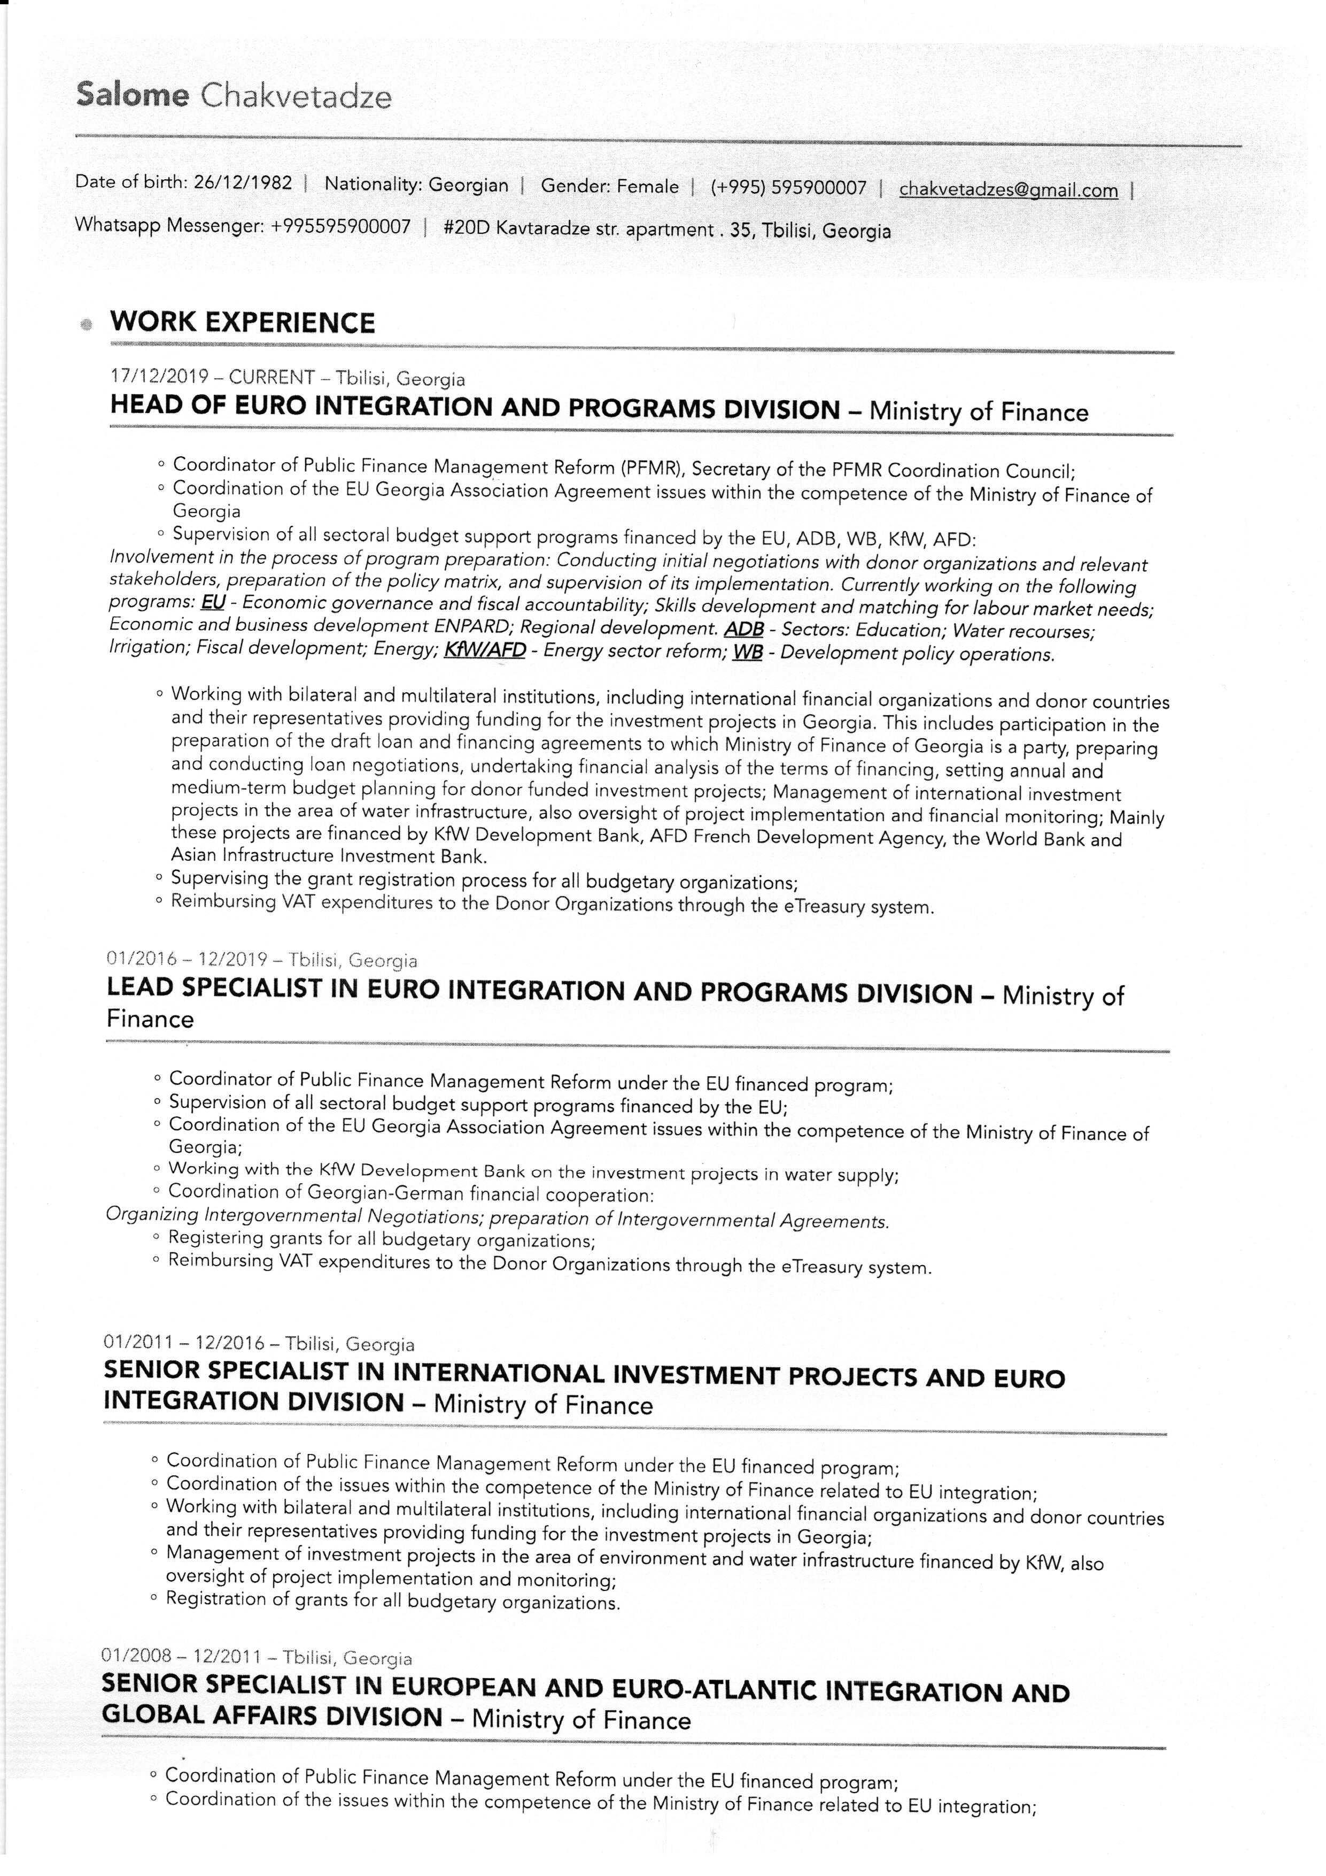

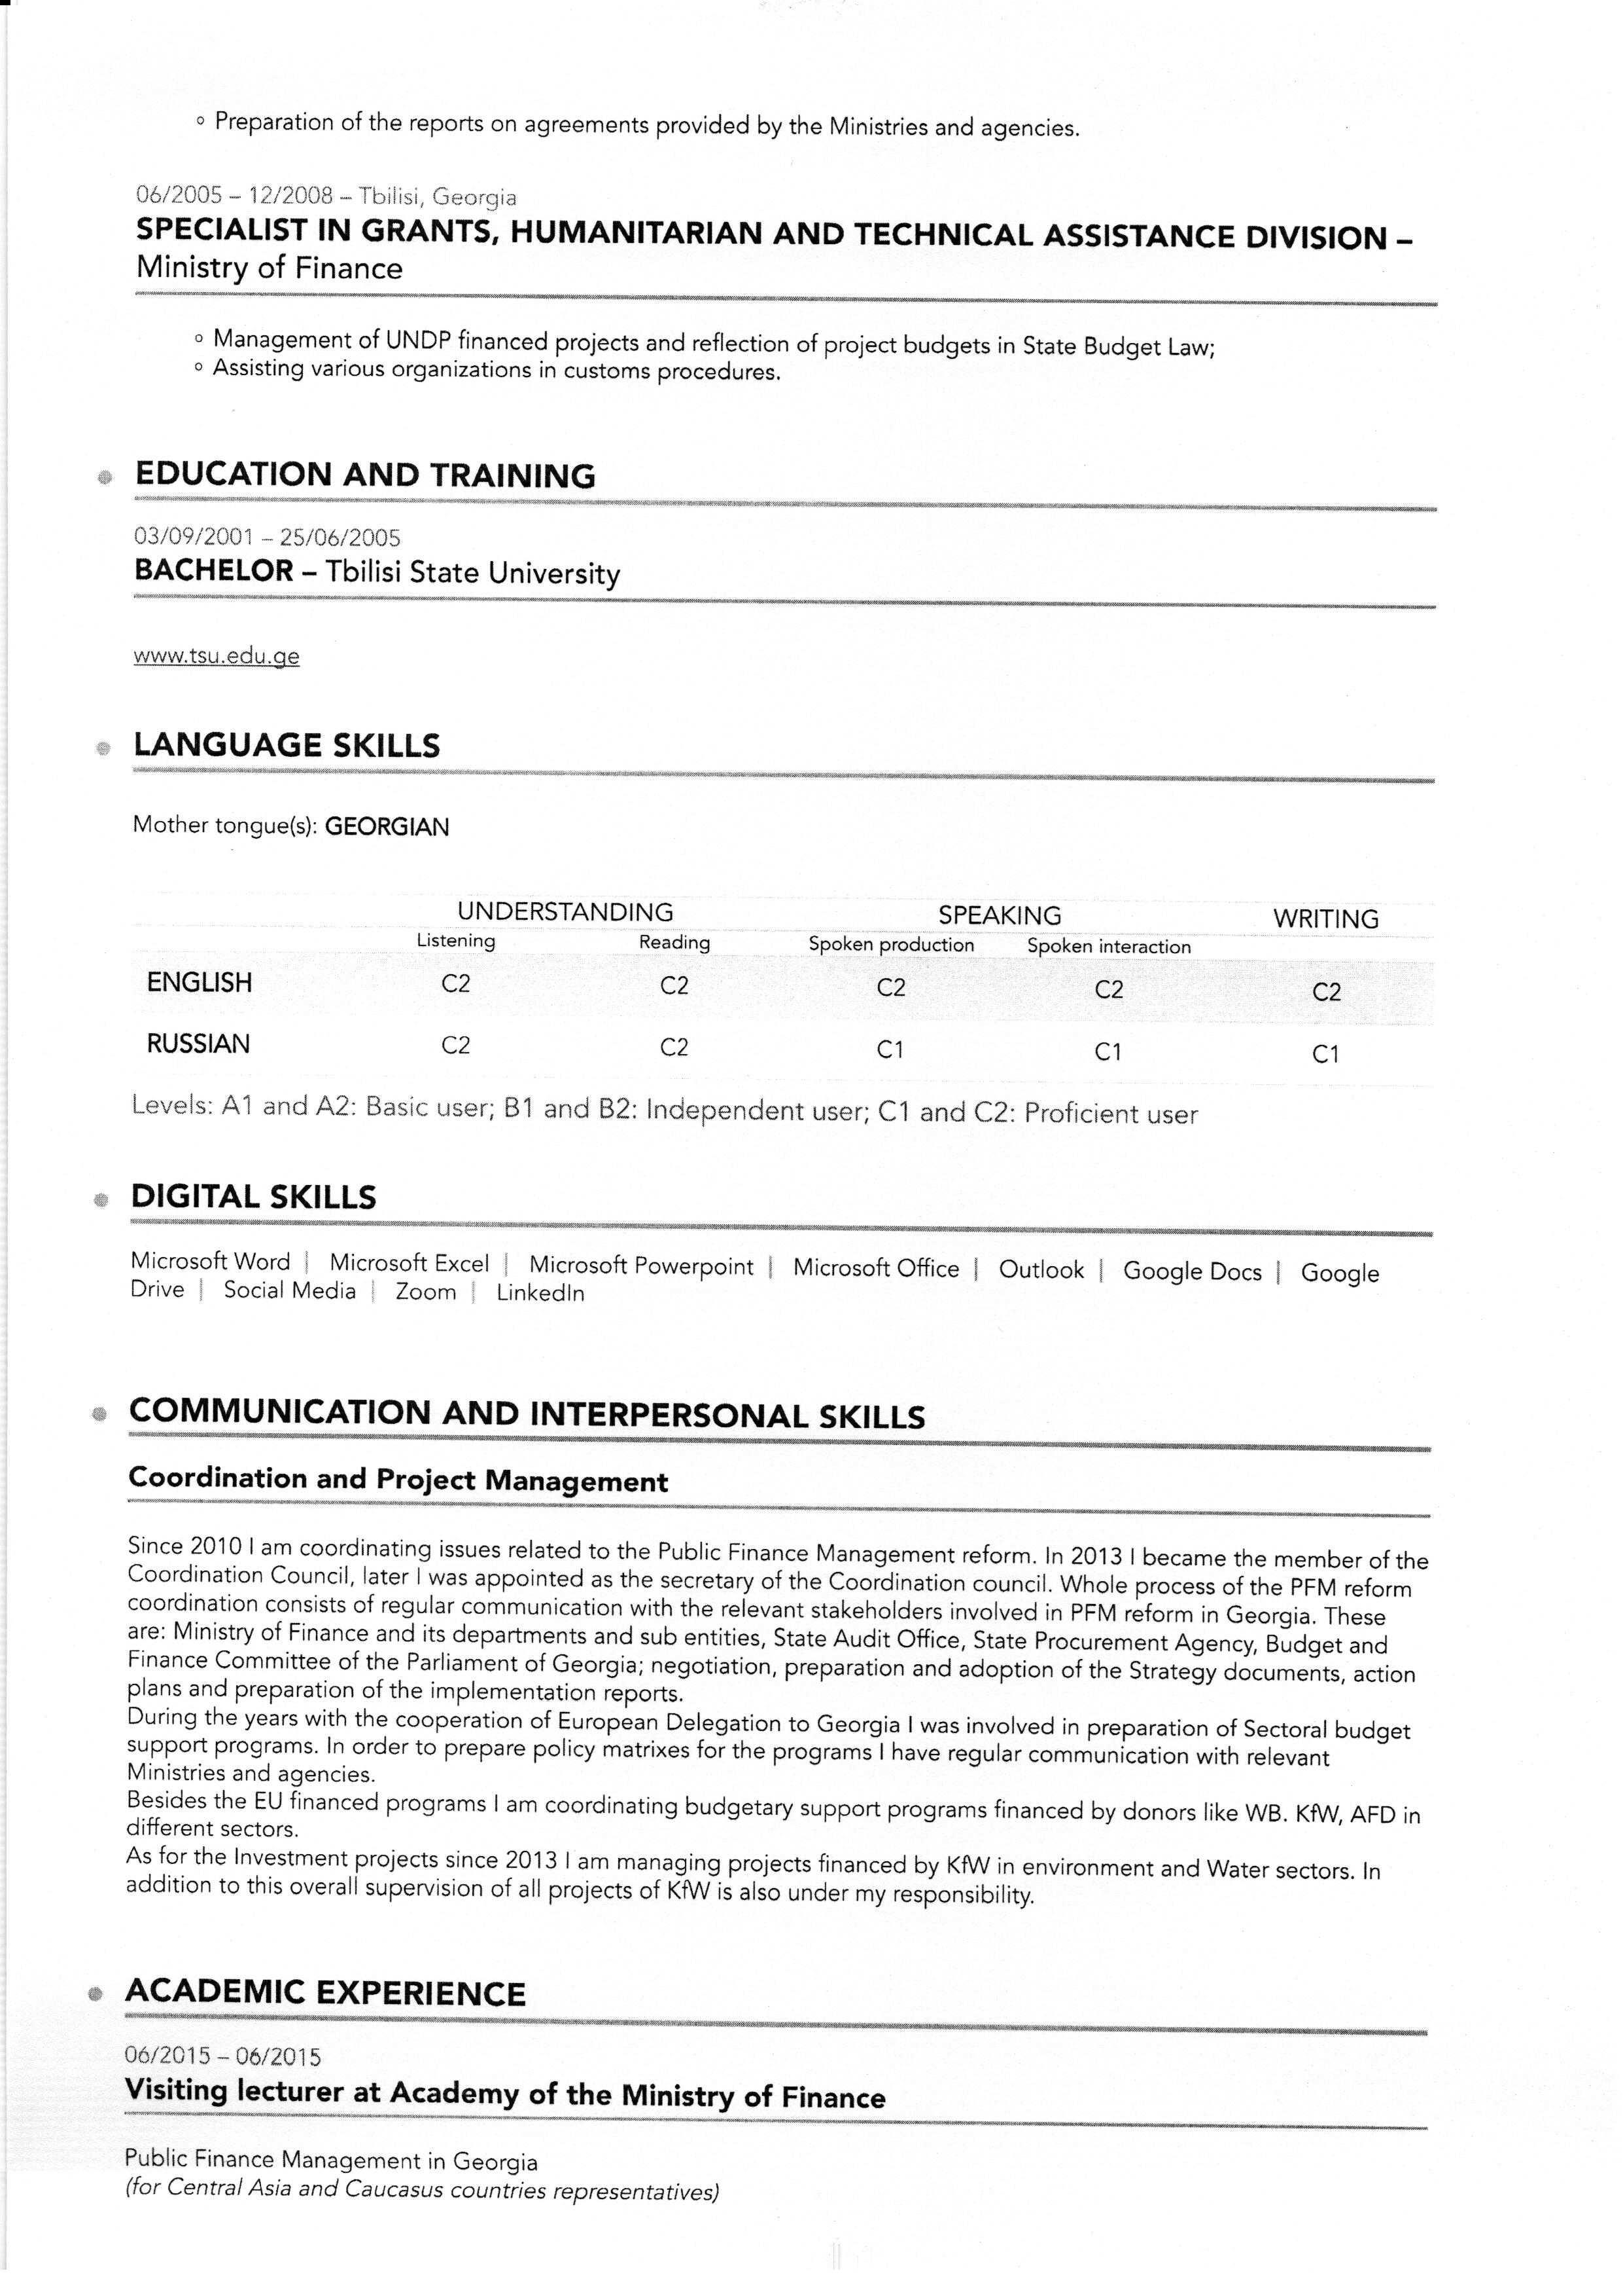

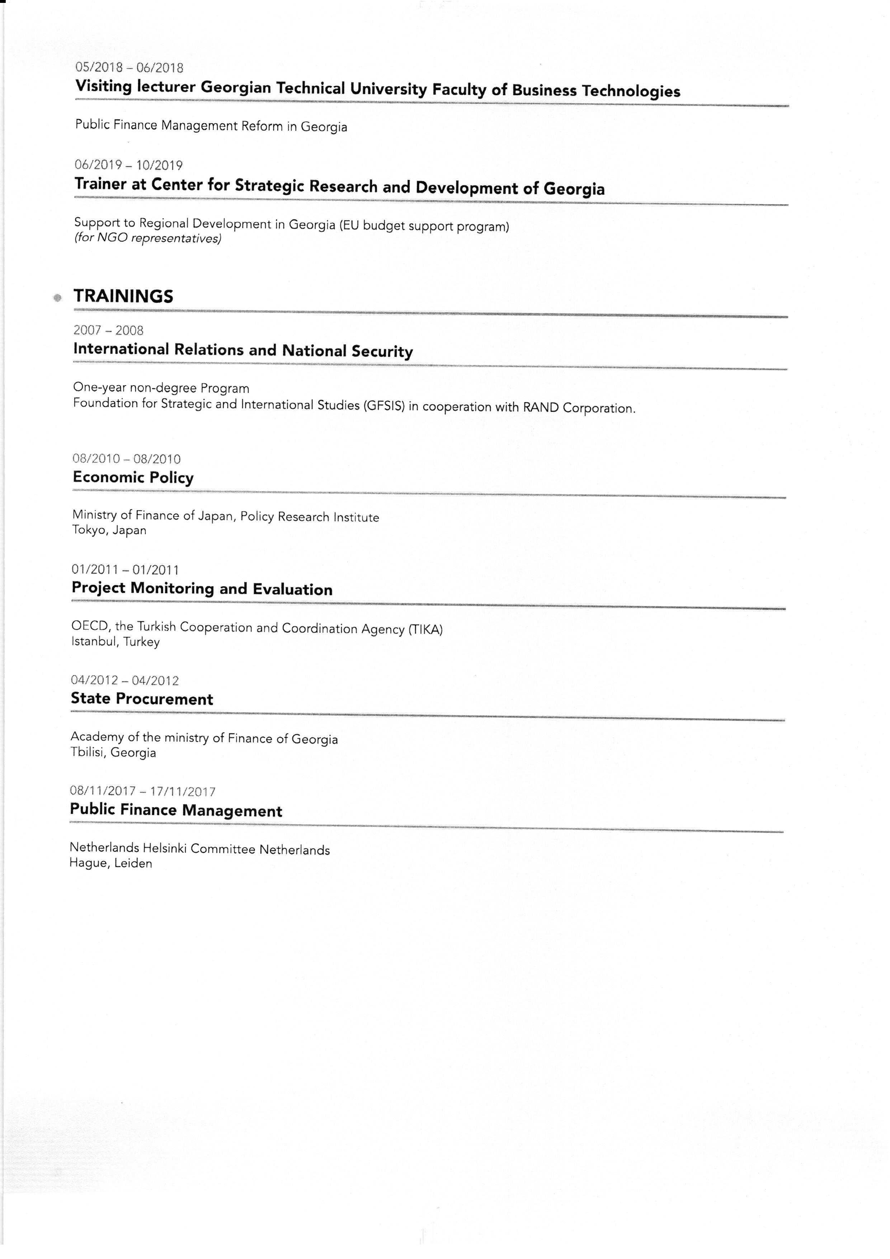

Supplement to project title, if this is not sufficiently informative.
Capitalised terms used, but not otherwise defined in this Declaration of Undertaking have the meaning given to such term in KfW’s “Guidelines for the Procurement of Consulting Services, Works, Goods, Plant and Non-Consulting Services in Financial Cooperation with Partner Countries”.
The PEA means the purchaser, the employer, the client, as the case may be, for the procurement of Consulting Services, Works, Plant, Goods or Non-Consulting Services.
In case ILO conventions have not been fully ratified or implemented in the Employer’s country the Applicant/Bidder/Contractor shall, to the satisfaction of the Employer and KfW, propose and implement appropriate measures in the spirit of the said ILO conventions with respect to a) workers grievances on working conditions and terms of employment, b) child labour, c) forced labour, d) worker’s organisations and e) non-discrimination.

